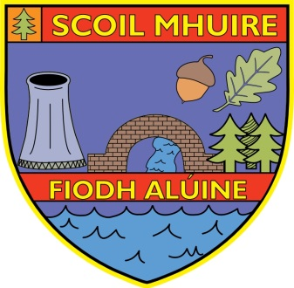
Scoil Mhuire Allenwood
Allenwood
Naas
Co. Kildare

Principal: Carole Fenton
Phone 045 860826 / 860098
e-mail scoilmaw@gmail.com Website: www.scoilmhuireallenwood.ie Roll:20505S
___________________________________________________________________________
Protocol for visitors

Essential visits to the school during the school day should be by prior arrangement.
Visitors will be received at the school office in the front/back building.
Visitors must wear a face covering and must complete the contact tracing log,
Physical distancing of 2 metres should be maintained with visitors where possible.
In relation to drop off of forgotten items (books lunch boxes) the visitors must
contact the office and drop off the item in the school porch.

Contact Details:

Front Office 045 860098

Back Office 045 860826

